Rocking Shaker—RS200
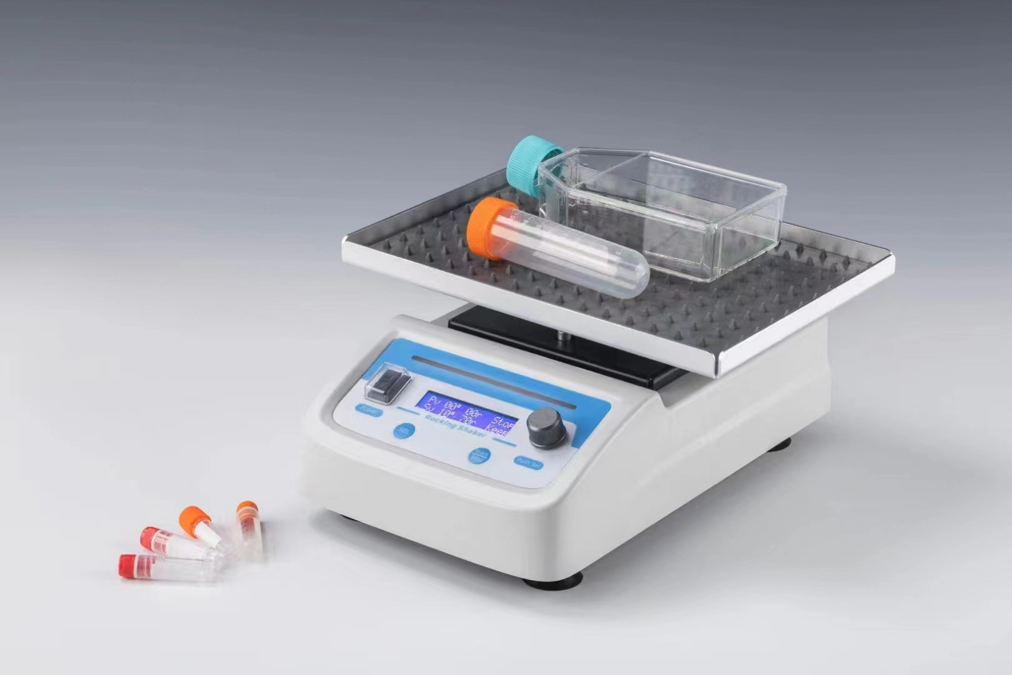
Description:
RS200 Rocking Shaker is a table oscillator that can be directly placed in a greenhouse or incubator. It combines step motor and microcomputer technology. Adjustable tilt angle and precise digital speed control providing desired rocking motion. It is specially designed for 2D shaking of test tube, culture dish, cell culture plate and so on. It’s ideal device for bio molecular hybridization and for staining/ destaining procedures in electrophoresis and homogenization.

Feature：
- LCD display for tilt angle, speed and time.
- See-saw like motion.
- Easy to adjust tilt angle(1~10°) and speed range(1~70rpm).
- Electronic control allows simple tilt angle, speed and time adjustments
while the unit is till running to achieve optimal mixing.
- Step motor: noiseless, less interference and maintenance-free.
- The dimpled mat prevents different size tubes from rolling around the
platform.
- Beep alarm when operation ends.
- Compact designed, take up very little space.
- Support 5 custom procedures, convenient for quick use.

3. The basic parameters and performance
Project | Parameters
Speed range | 1~70rpm
Tilt angle | 1~10°
Time range | 1min~99h59min/∞
Max. load | 2.0kg
Platform material | Aluminum
Platform dimension | 248x185mm
Power supply | 35W
Voltage | DC24V/2A
Dimension(mm) | 294x254x128mm
Weight | 2.8kg

